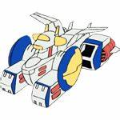

White Base

Launch your Mobile Suit and engage your daily battle

Revision 0.0.0.0

Table of Contents
Abstract 3
Release Notes 4
Release 0.0.0.0 4

Abstract
This is an application launcher that let you decide what is relevant, and try to re-balance automation and your discretion.

Release Notes

Release 0.0.0.0
Project scaffolding

